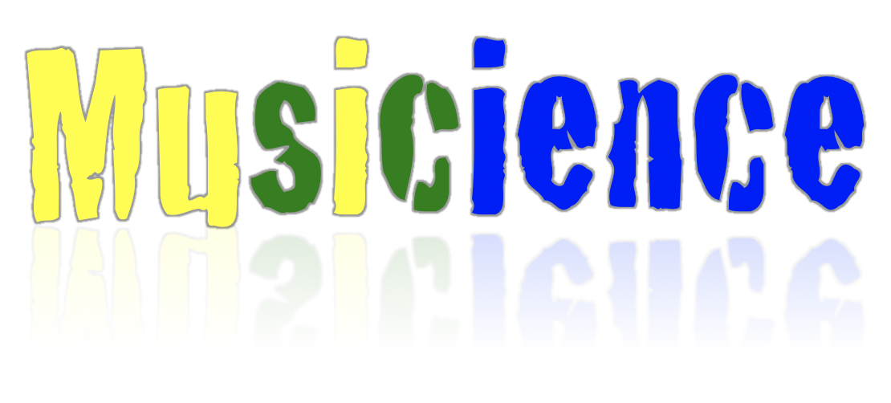

Performed with
Muncie Symphony Orchestra (IN)
Fox Valley Orchestra (IL)
The Chappaqua Orchestra (NY)



Douglas Droste, Conductor
Dr. Patrick Herak, Guest Scientist

General Questions or comments may be directed to Douglas Droste at
dpdroste@bsu.edu

Questions regarding science content may be sent to directly to Dr. Herak at
herak.1@osu.edu

Table of Contents

Sample Concert Program …….…………………………………………………………... | 3
About the Educator Resources …………………………………………………………... | 4
Writing Prompts ……………………………………………………………………………. | 5
Science Activities ………………………………………………………………………...... | 6
Correlation to Indiana State Science Standards (grades 4-6) ………………………… | 9
APPENDIX - Dancer Pictures ……………………………………………………………. | 16

Concert Program

Mike HIMELSTEIN Sid the Science Kid Theme
Dena DIAMOND

Ari PULKKINEN Angry Birds theme

Johann STRAUSS II Blue Danube Waltz #1

Joseph HAYDN Piano Concerto in D Major
1st movement
Rowan Squire-Willey, piano

Leroy ANDERSON Fiddle Faddle

Joseph HAYDN Symphony. No. 94 “Surprise”
Movement 2

Reinhold GLIERE Russian Sailor’s Dance

Aaron COPLAND Hoedown from Rodeo
Featuring Premiere Studio

Pyotr Ilyich TCHAIKOVSKY 1812 Overture (excerpt)

About the Educator Resources

In addition to this Packet, there is a PowerPoint that details musical concepts and relates them to science. This PowerPoint can either be used as a teacher reference or shared with students.

Key Terms and Discussion Prompts are typed in green to facilitate their identification. Additionally, there are educator notes at the bottom of many of the slides to give extra help to teachers. If there are any explanations that are unclear or need for additional assistance, you may contact Dr. Herak directly for assistance (herak.1@osu.edu).

